1. Create a simple cloud software application for Flight Reservation System using any Cloud Service Provider to demonstrate SaaS include the necessary fields such as one way, round trip, From, to, Departure, Departure, Travelers &amp; Class, Fare Type, International andDomestic Flights etc.
AIM:
To create a simple cloud software application for flight reservation system using
any cloud service provider to demonstrate saas.
PROCEDURE:
step1: Go to zoho.com.
step 2: Log into the zoho.com.
step 3: Select one application step.
step4: Enter application name as flight reservation system.
step 5: Created new application flight reservation system.
step 6: Select one form
step 7: The software has been created.
IMPLEMENTATION: 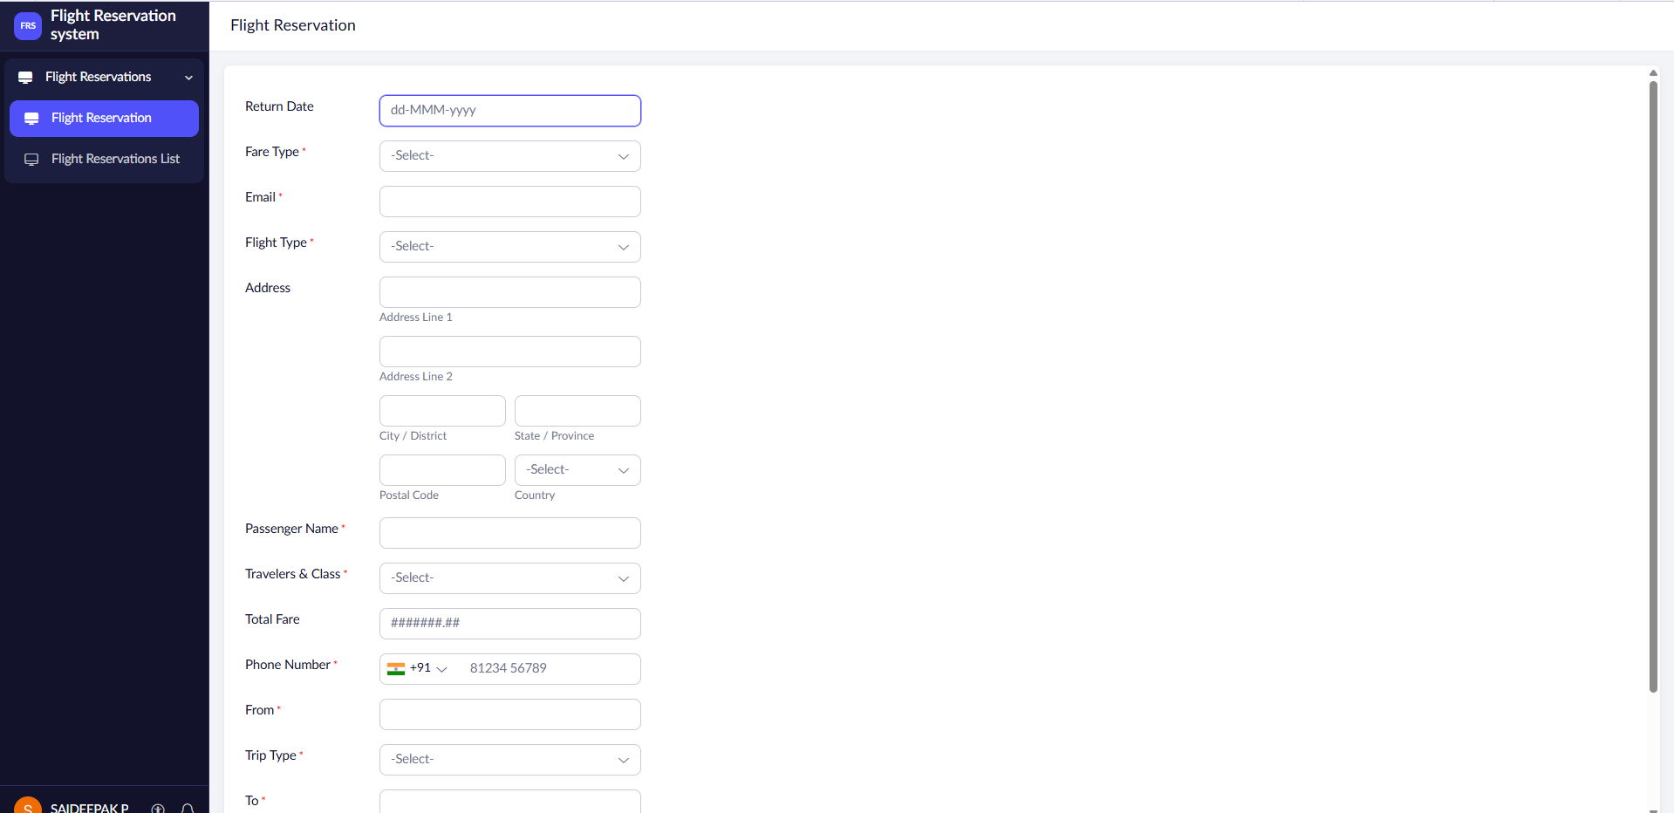

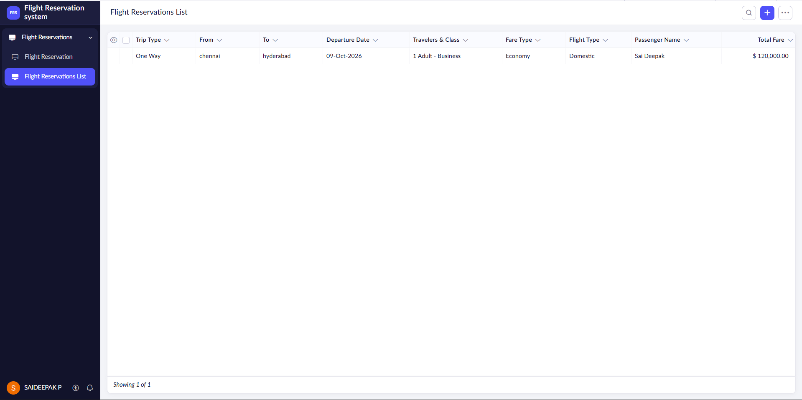
RESULT: Successfully created a simple cloud software application for flight reservation system using zoho.

2. Create a simple cloud software application for Property Buying &amp; Rental process (In Chennaicity) using any Cloud Service Provider to demonstrate SaaS include the necessary fields such as Buy, Rent, commercial, Rental Agreement , Rental Agreement, Area, place, Range,property value etc.
AIM:
To Create a simple cloud software application for Property Buying & Rental process
(In Chennai city) using any Cloud Service Provider to demonstrate SaaS.
PROCEDURE:
step1: Go to zoho.com.
step 2: Log into the zoho.com.
step 3: Select one application step.
step4: Enter application name as property buying & rental.
step 5: Created new application as property buying & rental.
step 6: Select one form
step 7: The software has been created.
IMPLEMENTATION: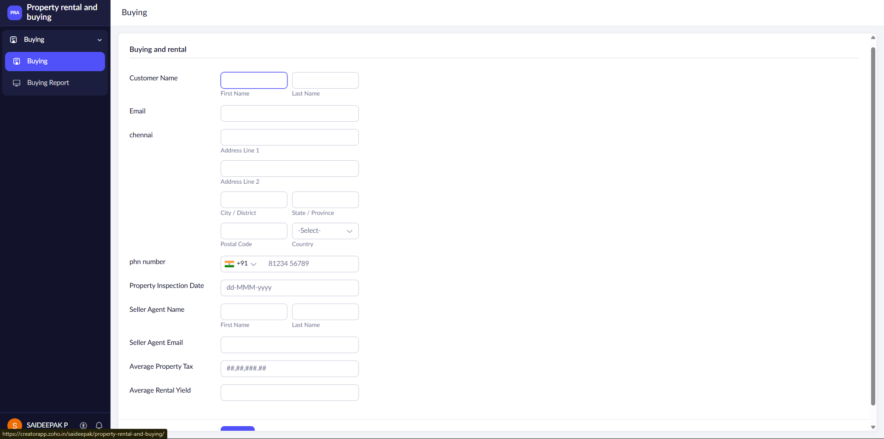

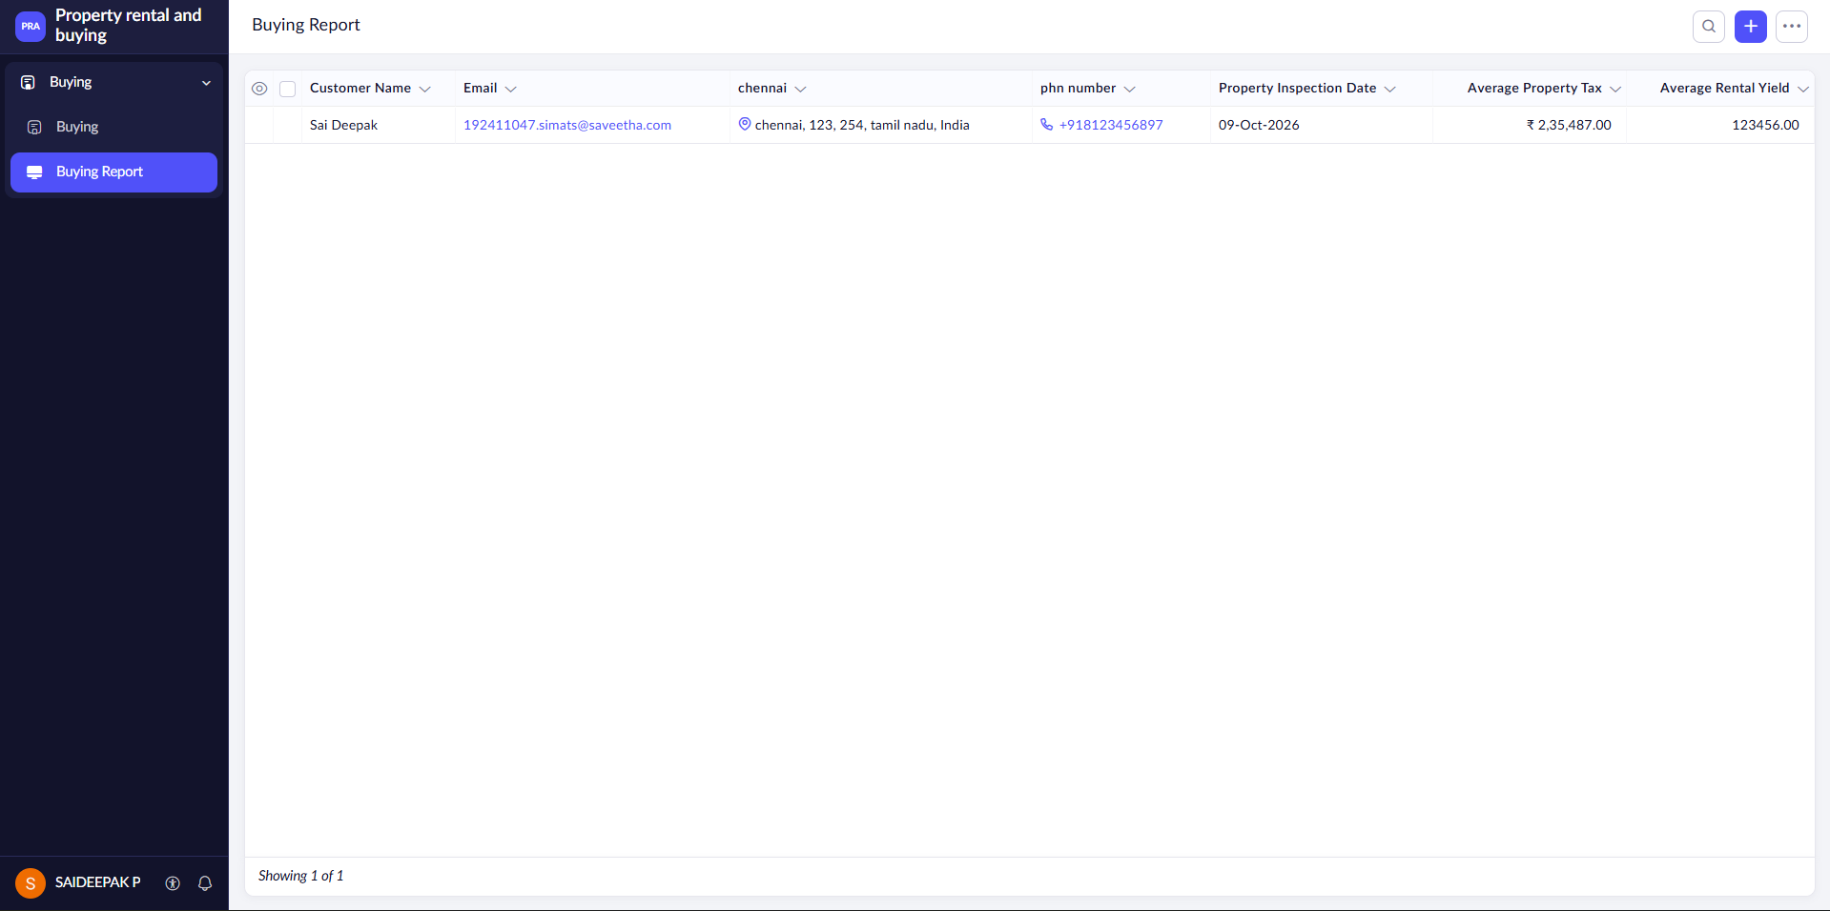
RESULT: Successfully created a simple cloud software application for Property Buying & Rental system using zoho.

3. Create a simple cloud software application for Car Booking Reservation System using any Cloud Service Provider to demonstrate SaaS include the necessary fields such as search for cabs, from, to, rental , out station, Package type, hours/Days etc.
AIM:
To Create a simple cloud software application for Car Booking Reservation System
using any Cloud Service Provider to demonstrate SaaS.
PROCEDURE:
step1: Go to zoho.com.
step 2: Log into the zoho.com.
step 3: Select one application step.
step4: Enter application name as Car Booking Reservation System.
step 5: Created new application as Car Booking Reservation System.
step 6: Select one form
step 7: The software has been created.
IMPLEMENTATION:
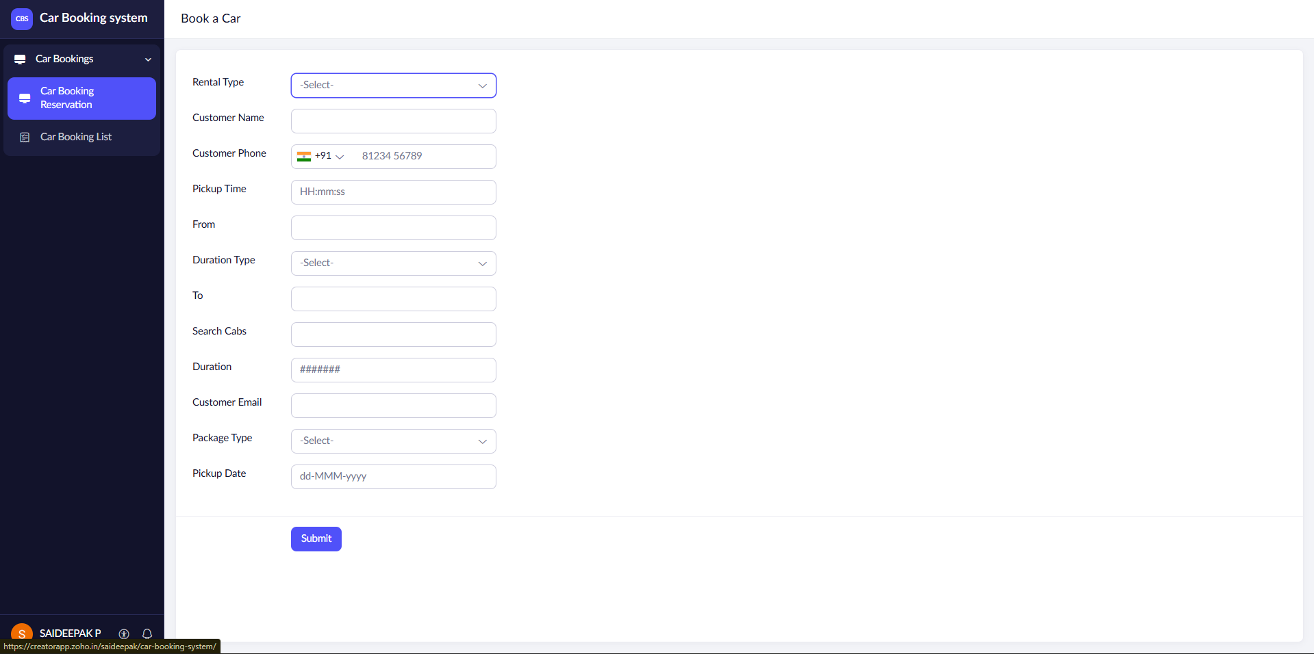

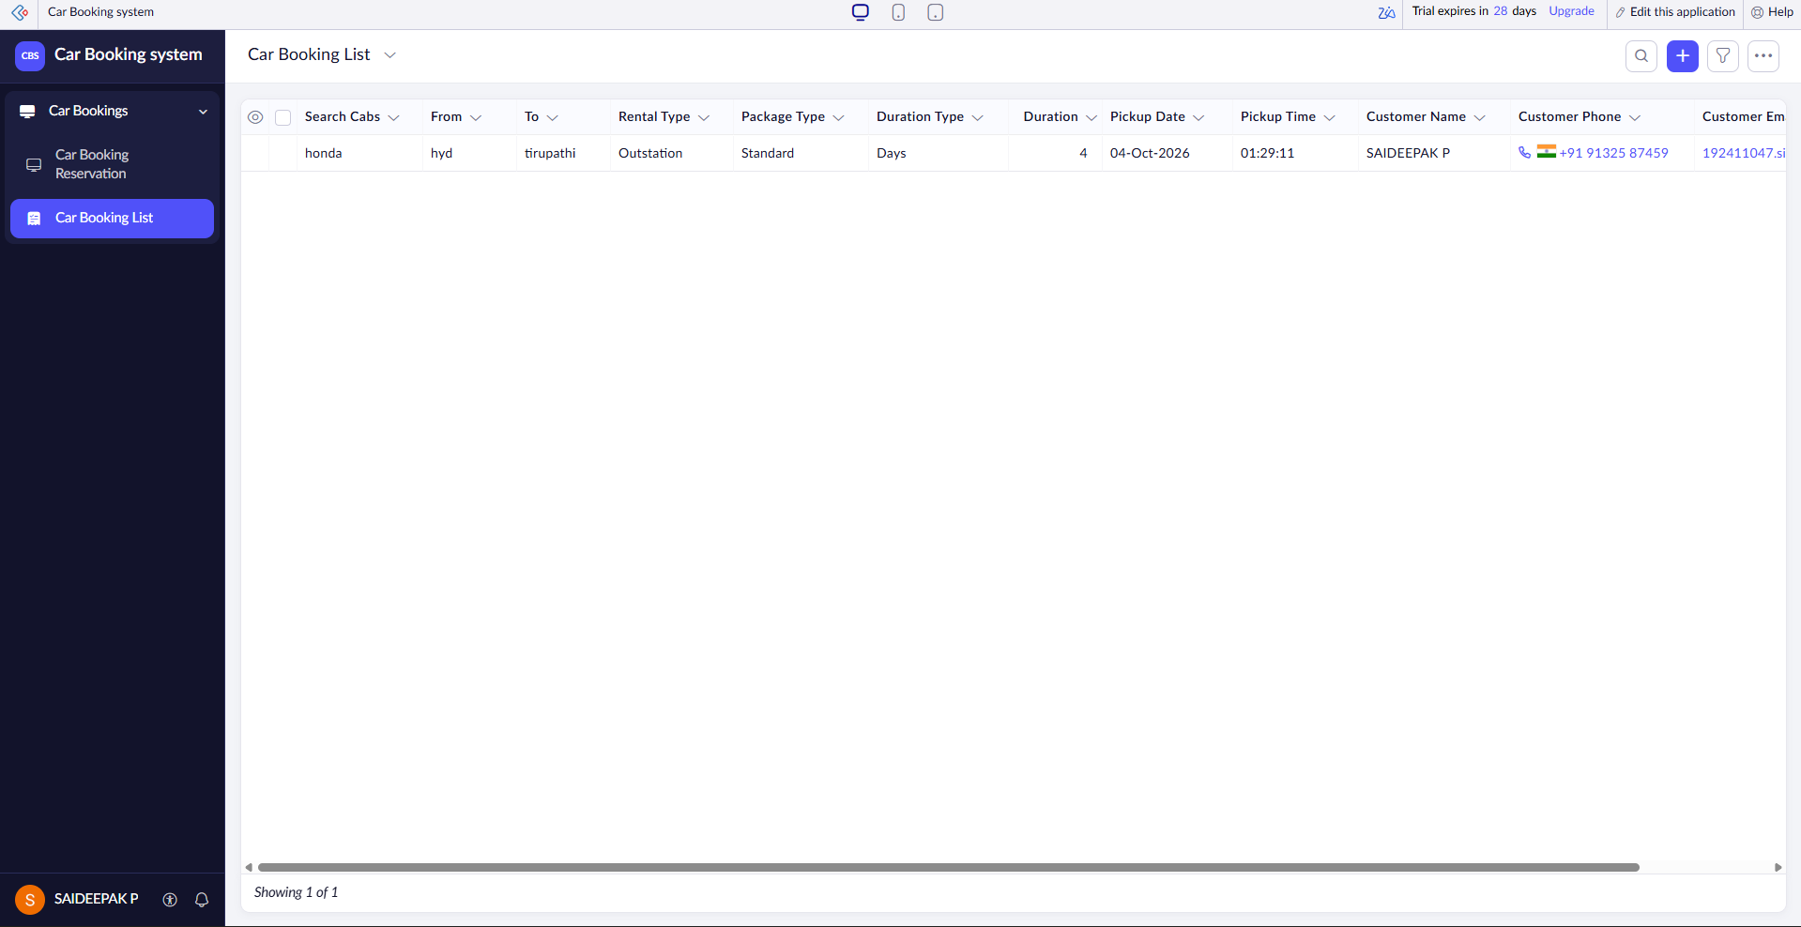
RESULT: Successfully created a simple cloud software application for Car Booking Reservation system using zoho.

4. Create a simple cloud software application for Library book reservation system for SIMATS library using any Cloud Service Provider to demonstrate SaaS include the necessary fields such as Title of the book, author, publications, Year, edition, no of copies, Rack no, status (taken/returned) etc.
AIM:
To Create a simple cloud software application for Library book reservation system for
SIMATS library using any Cloud Service Provider to demonstrate SaaS
PROCEDURE:
step1: Go to zoho.com.
step 2: Log into the zoho.com.
step 3: Select one application step.
step4: Enter application name as library book reservation system.
step 5: Created new application as library book reservation system.
step 6: Select one form
step 7: The software has been created.

IMPLEMENTATION: 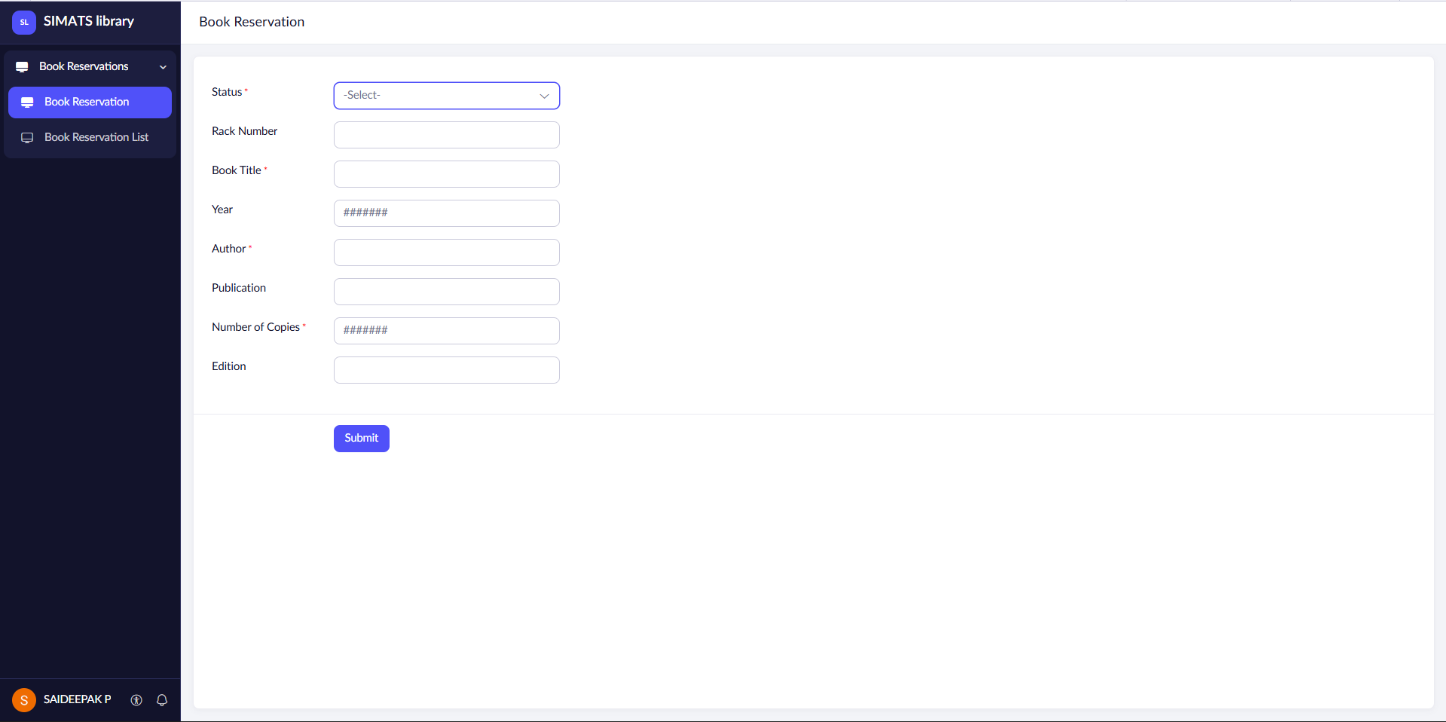

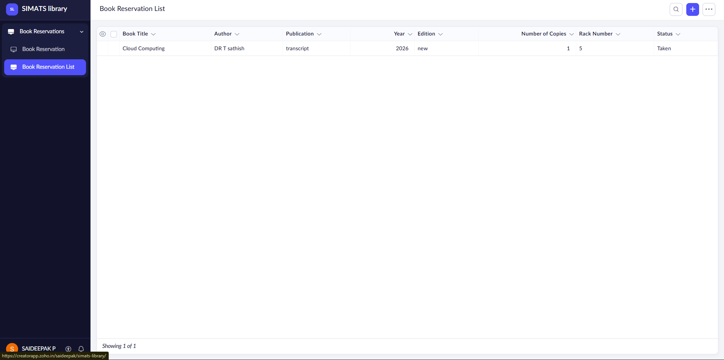
RESULT: Successfully created a simple cloud software application for Library book reservation system for SIMATS library using zoho.

5. Create a simple cloud software application for Mark Sheet Processing System using any
Cloud Service Provider to demonstrate SaaS include the necessary fields such as name of the student, Reg no of the student , Subjects , Marks, Average, percentage, rank, overall
performance etc.
AIM:
To Create a simple cloud software application for Mark Sheet Processing System using any Cloud Service Provider to demonstrate SaaS.
PROCEDURE:
step1: Go to zoho.com.
step 2: Log into the zoho.com.
step 3: Select one application.
step 4: Enter application name as Mark Sheet Processing System.
step 5: Create new application as Mark Sheet Processing System.
step 6: Select one form and add fields such as Name of the Student, Reg No, Subjects, Marks, Average, Percentage, Rank and Overall Performance.
step 7: The software has been created.
IMPLEMENTATION: 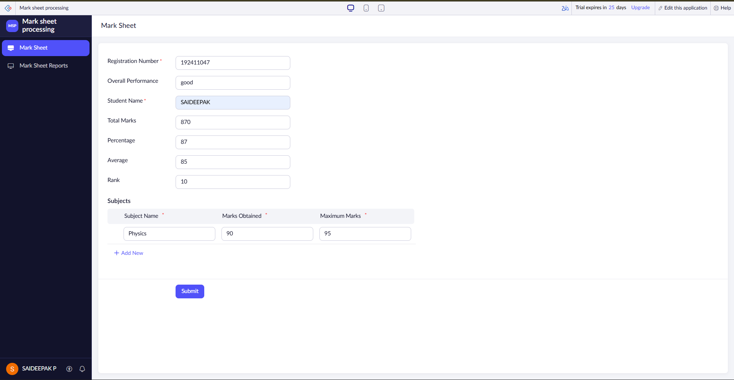
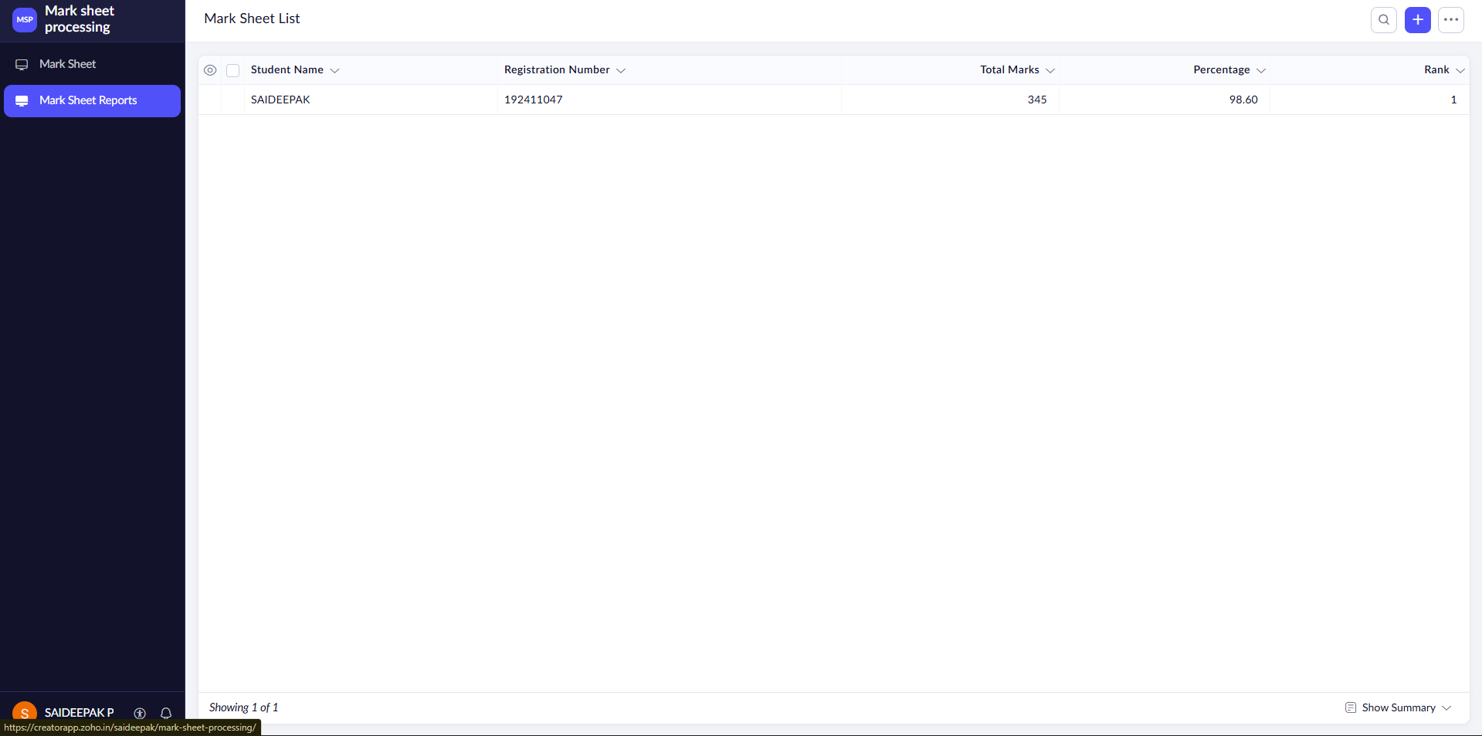
RESULT: Successfully created a simple cloud software application for Mark Sheet Processing System using zoho.

6. Create a simple cloud software application for Payroll Processing System using any Cloud
Service Provider to demonstrate SaaS include the necessary fields such as Name of the
employee, experience in present org , over all experience, basic pay, HRA, DA, TA, net pay,
gross pay etc.
AIM:
To Create a simple cloud software application for Payroll Processing System using any Cloud Service Provider to demonstrate SaaS.
PROCEDURE:
step1: Go to zoho.com.
step 2: Log into the zoho.com.
step 3: Select one application.
step 4: Enter application name as Payroll Processing System.
step 5: Create new application as Payroll Processing System.
step 6: Select one form and add fields such as Name of the Employee, Experience in Present Organization, Overall Experience, Basic Pay, HRA, DA, TA, Net Pay and Gross Pay.
step 7: The software has been created.
IMPLEMENTATION:
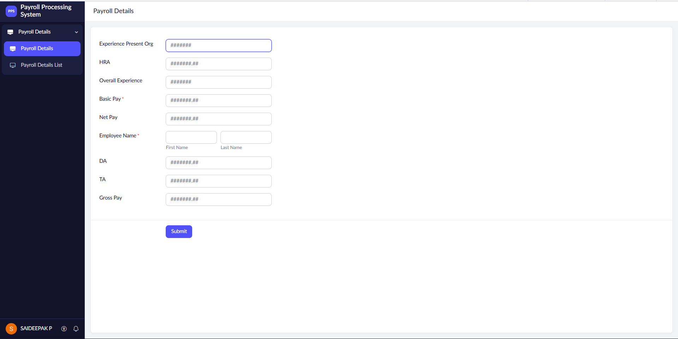
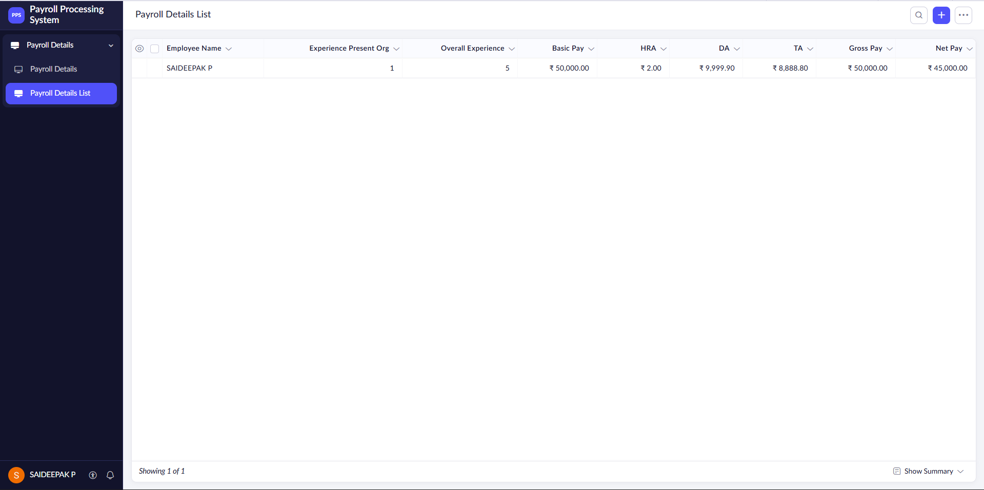
RESULT: Successfully created a simple cloud software application for Payroll Processing System using zoho.

7. Create a simple cloud software application for Students Attendance System using any Cloud Service Provider to demonstrate SaaS include the necessary fields such as name of the students, course, present , Absent, course attendance, OD request, grade, attendance
percentage, etc.
AIM:
To Create a simple cloud software application for Students Attendance System using any Cloud Service Provider to demonstrate SaaS.
PROCEDURE:
step1: Go to zoho.com.
step 2: Log into the zoho.com.
step 3: Select one application.
step 4: Enter application name as Students Attendance System.
step 5: Create new application as Students Attendance System.
step 6: Select one form and add fields such as Name of the Student, Course, Present, Absent, Course Attendance, OD Request, Grade and Attendance Percentage.
step 7: The software has been created.
IMPLEMENTATION:
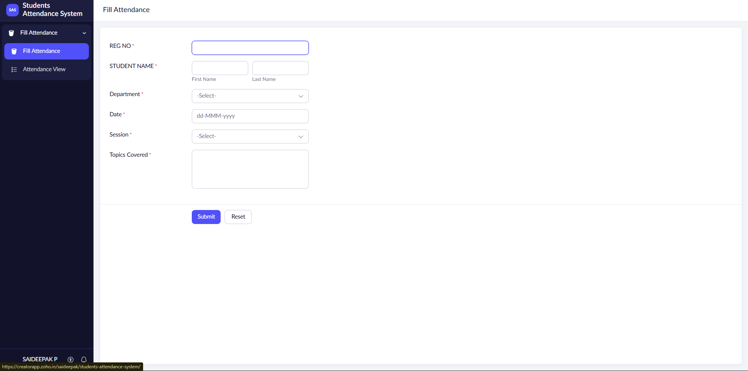

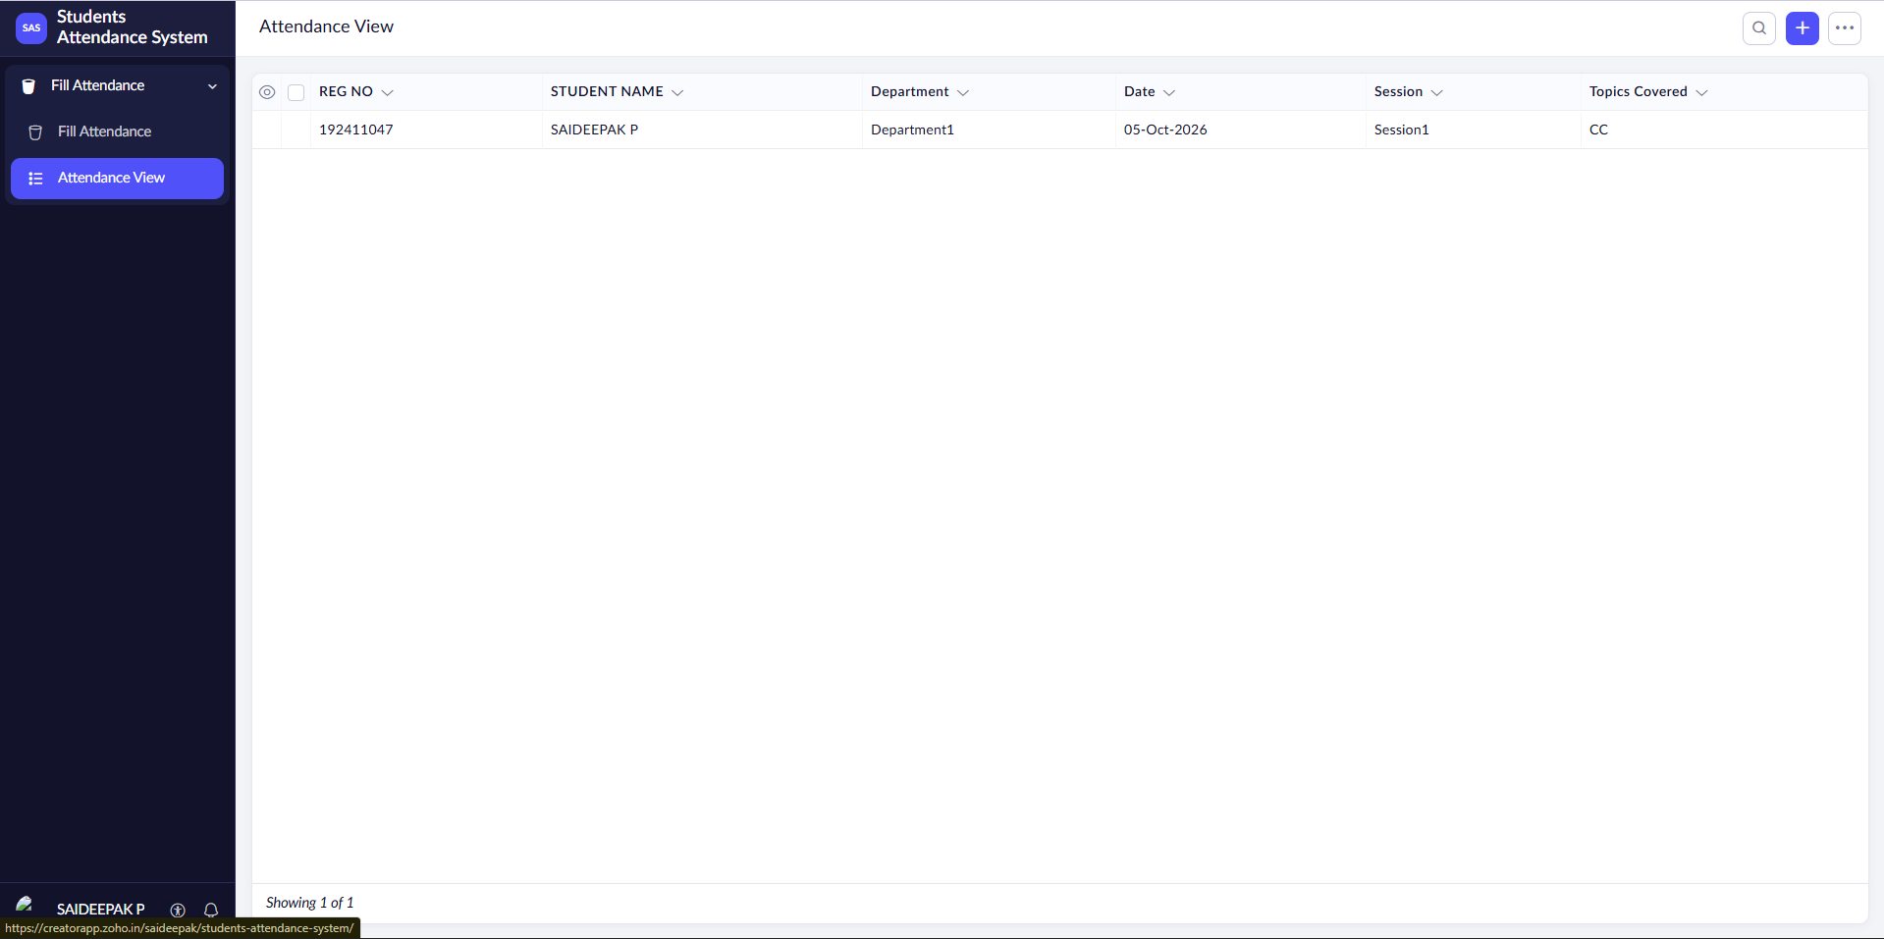
RESULT: Successfully created a simple cloud software application for for Students Attendance System using zoho.

8. Create a simple cloud web application for student counselling system using any Cloud
Service Provider to demonstrate SaaS with the fields of student name, age, address, phone,
subjects studied, Year of passing, percentage of marks, domain interest, etc.
AIM:
To Create a simple cloud web application for Student Counselling System using any Cloud Service Provider to demonstrate SaaS.
PROCEDURE:
step1: Go to zoho.com.
step 2: Log into the zoho.com.
step 3: Select one application.
step 4: Enter application name as Student Counselling System.
step 5: Create new application as Student Counselling System.
step 6: Select one form and add fields such as Student Name, Age, Address, Phone, Subjects Studied, Year of Passing, Percentage of Marks and Domain Interest.
step 7: The software has been created.
IMPLEMENTATION:
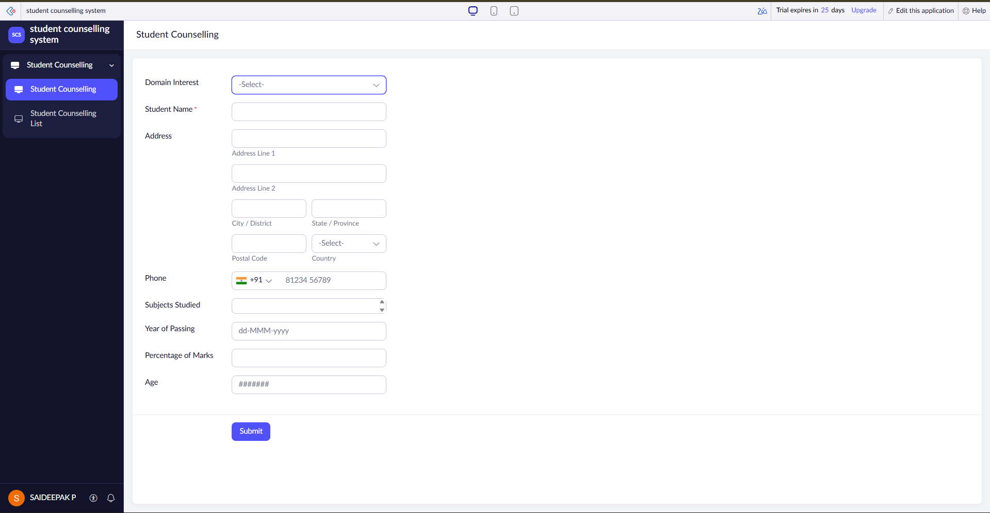

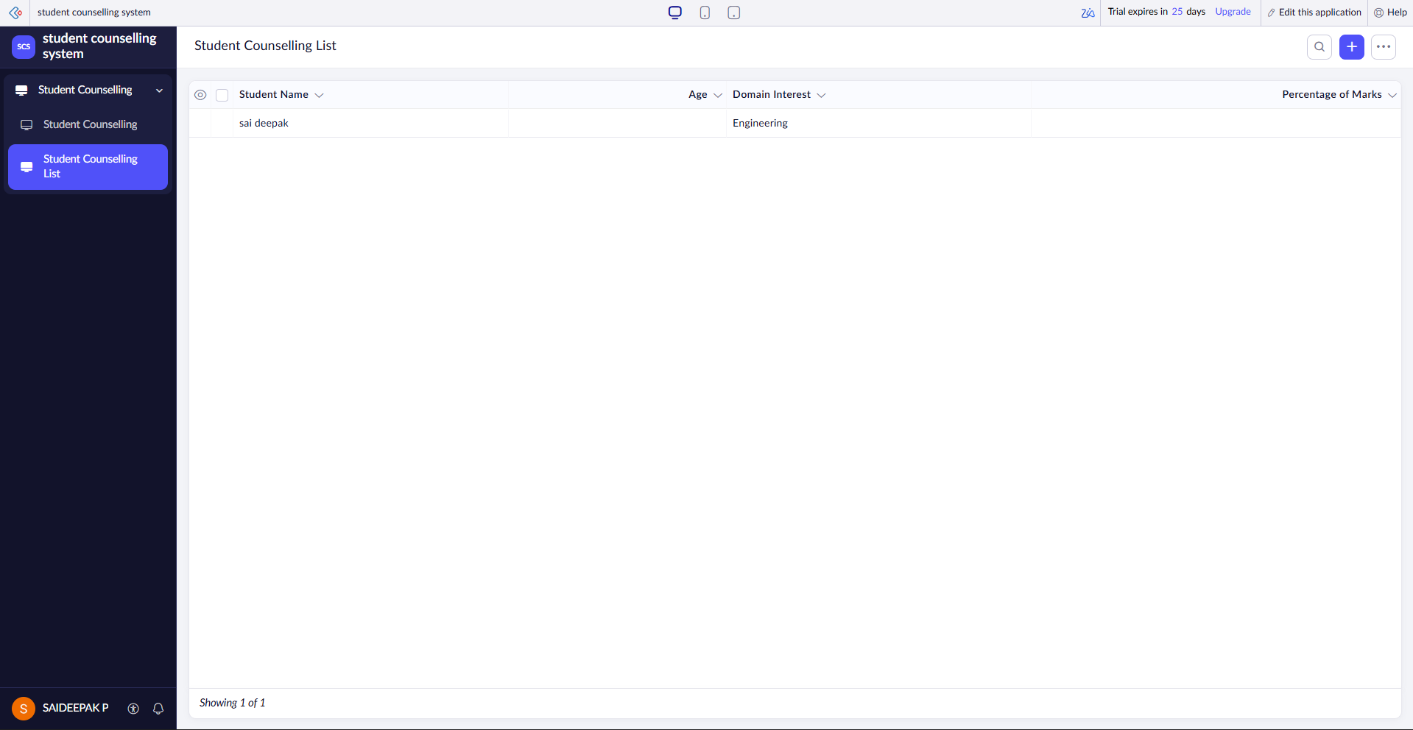
RESULT: Successfully created a simple cloud software application for for Students Counseiling System using zoho.

9. Create a simple cloud software application for Hospital information system for SIMATS
Hospital using any Cloud Service Provider to demonstrate SaaS with fields of patient name,
age, address, phone, email, Attender name, attender phone, doctor name, diseases, etc.
AIM:
To Create a simple cloud software application for Hospital Information System for SIMATS Hospital using any Cloud Service Provider to demonstrate SaaS.
PROCEDURE:
step1: Go to zoho.com.
step 2: Log into the zoho.com.
step 3: Select one application.
step 4: Enter application name as Hospital Information System.
step 5: Create new application as Hospital Information System.
step 6: Select one form and add fields such as Patient Name, Age, Address, Phone, Email, Attender Name, Attender Phone, Doctor Name and Diseases.
step 7: The software has been created.
IMPLEMENTATION:
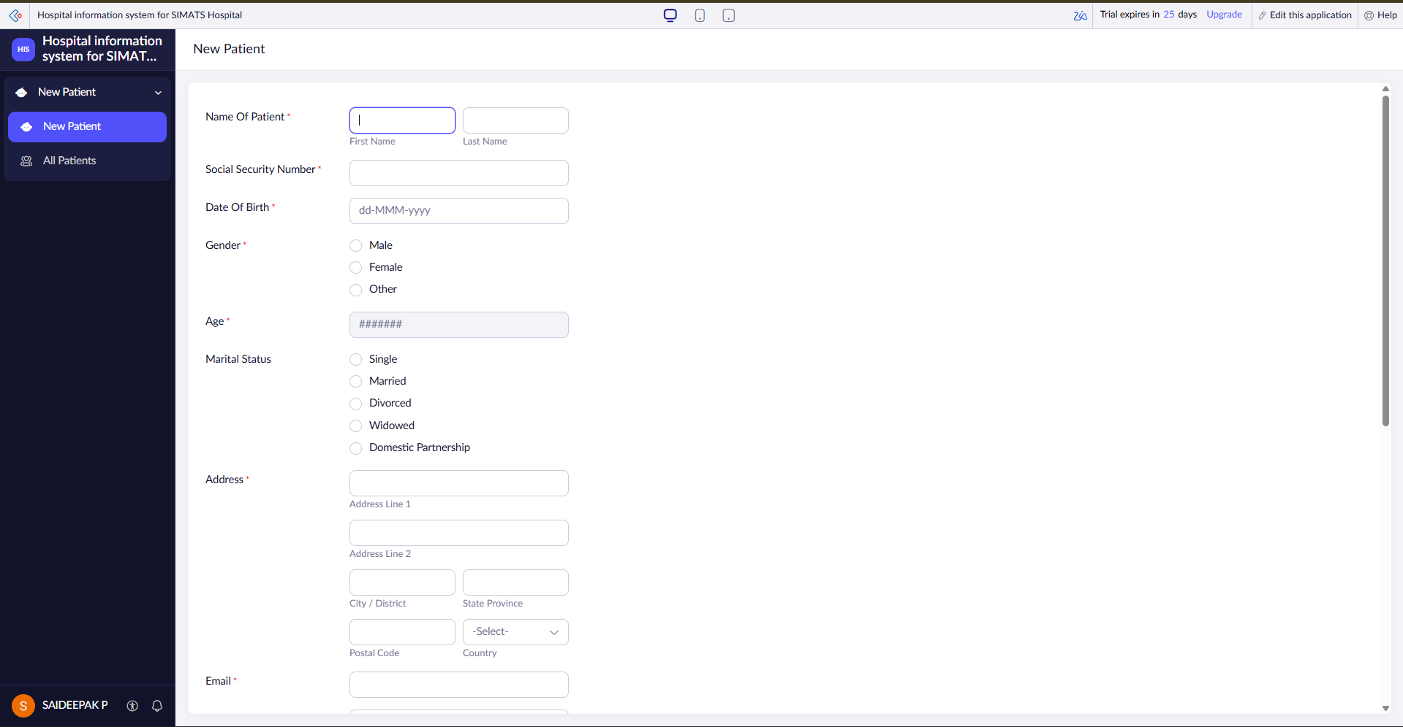

RESULT: Successfully created a simple cloud software application for Hospital information system for SIMATS Hospital using zoho.

10. Create a simple cloud software application to run a c program to display the student
information using any Cloud Service Provider to demonstrate SaaS with the template of
student name, reg no, address, phone, age, courses, grades and attendance report, progress
report, Semester mark sheet forms.
AIM:
To Create a simple cloud software application to run a C program to display the Student Information using any Cloud Service Provider to demonstrate SaaS.
PROCEDURE:
step1: Go to zoho.com.
step 2: Log into the zoho.com.
step 3: Select one application.
step 4: Enter application name as Student Information System.
step 5: Create new application as Student Information System.
step 6: Select forms and add fields such as Student Name, Reg No, Address, Phone, Age, Courses, Grades, Attendance Report, Progress Report and Semester Mark Sheet.
step 7: The software has been created.
IMPLEMENTATION:
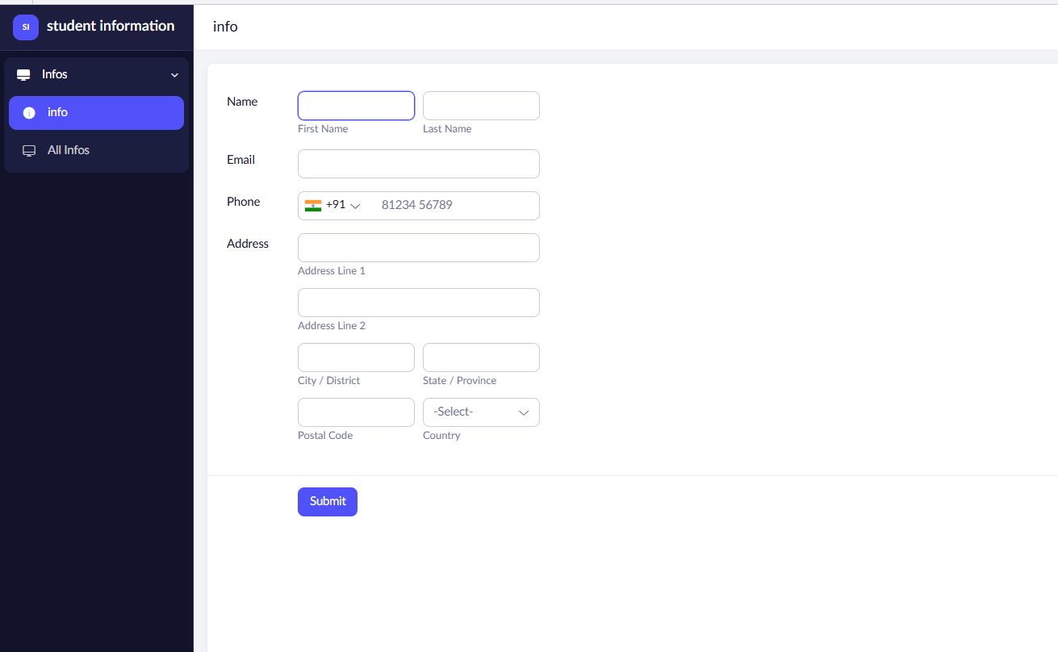
RESULT: Successfully created a simple cloud software application for Student Information using zoho.

11. Create a simple cloud software application for online super market using any Cloud Service Provider to demonstrate SaaS with the template of customer name, address, phone, email, items, quantity etc. with the item classification form.
AIM:
To Create a simple cloud software application for Online Super Market using any Cloud Service Provider to demonstrate SaaS.
PROCEDURE:
step1: Go to zoho.com.
step 2: Log into the zoho.com.
step 3: Select one application.
step 4: Enter application name as Online Super Market.
step 5: Create new application as Online Super Market.
step 6: Select one form and add fields such as Customer Name, Address, Phone, Email, Items and Quantity. Create an additional Item Classification form to classify the items.
step 7: The software has been created.
IMPLEMENTATION:
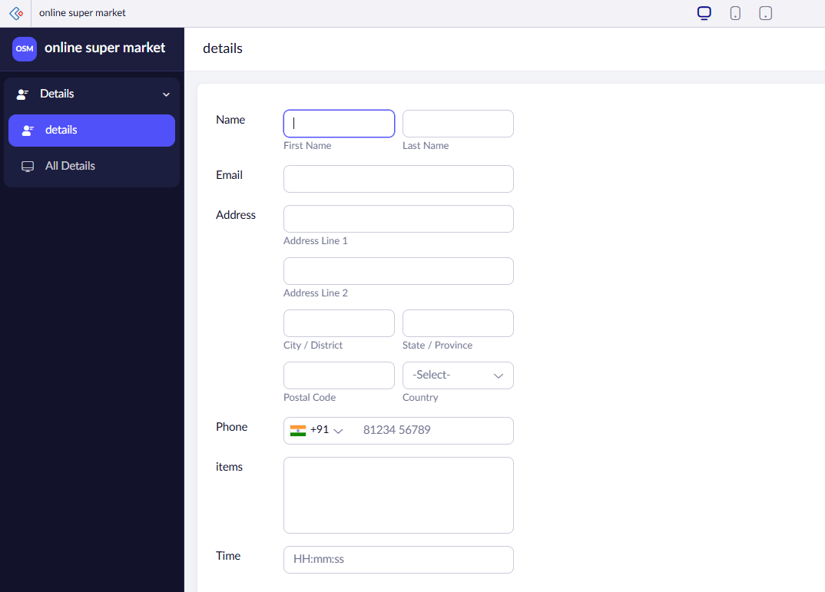
RESULT: Successfully created a simple cloud software application for Online super market using zoho.

